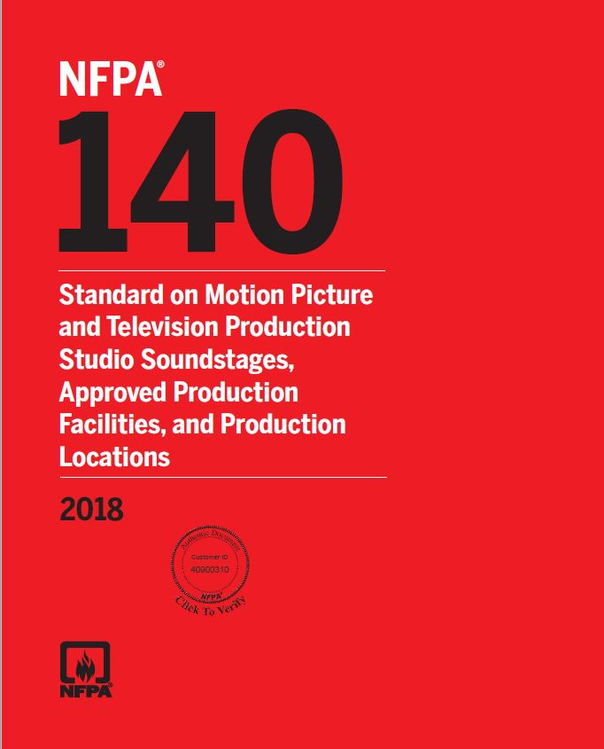

Contents
Chapter 1 Administration ............................................ 140– 4
1.1 Scope. ................................................................... 140– 4
1.2 Purpose. ............................................................... 140– 4
1.3 Application. .......................................................... 140– 4
1.4 Equivalency. ......................................................... 140– 4
Chapter 2 Referenced Publications ............................ 140– 4
2.1 General. ................................................................ 140– 4
2.2 NFPA Publications. .............................................. 140– 4
2.3 Other Publications. ............................................. 140– 5
2.4 References for Extracts in Mandatory Sections. 140– 5
Chapter 3 Definitions ................................................... 140– 5
3.1 General. ................................................................ 140– 5
3.2 NFPA Official Definitions. .................................. 140– 5
3.3 General Definitions. ............................................ 140– 5
Chapter 4 Soundstages and Approved Production
Facilities ...................................................... 140– 6
4.1 General. ................................................................ 140– 6
4.2 Permits. ................................................................ 140– 6
4.3 Pyrotechnic Special Effects and Open Flames. . 140– 6
4.4 Fire Watch. ........................................................... 140– 6
4.5 Decorative Materials. ........................................... 140– 6
4.6 Smoking. .............................................................. 140– 6
4.7 Structural Loads. ................................................. 140– 6
4.8 Electrical Requirements. ..................................... 140– 6
4.9 Fire Department Access. ..................................... 140– 7
4.10 Means of Egress. .................................................. 140– 7
4.11 Fire Protection. .................................................... 140– 7
4.12 Air Conditioning, Heating, and Ventilating. ..... 140– 7
Chapter 5 Production Locations ................................ 140– 7
5.1 General. ................................................................ 140– 7
5.2 Permits. ................................................................ 140– 7
5.3 Pyrotechnic Special Effects and Open Flames. . 140– 7
5.4 Fire Watch. ........................................................... 140– 7
5.5 Foamed Plastic Materials. .................................... 140– 8
5.6 Smoking. .............................................................. 140– 8
5.7 Structural Loads. ................................................. 140– 8
5.8 Electrical Requirements. ..................................... 140– 8
5.9 Fire Department Access. ..................................... 140– 8
5.10 Means of Egress. .................................................. 140– 8
5.11 Fire Protection. .................................................... 140– 8
Chapter 6 Operating Features ..................................... 140– 8
6.1 Waste or Refuse. .................................................. 140– 8
6.2 Flammable or Combustible Liquids. .................. 140– 8
6.3 Welding. ............................................................... 140– 8
6.4 Audience Life Safety. ........................................... 140– 8
6.5 Emergency Services Notification. ....................... 140– 8
Annex A Explanatory Material .................................. 140– 8
Annex B Informational References .......................... 140– 10
Index .....................................................................

4.10 Means of Egress.
Δ 4.10.1 Means of egress shall be in accordance with NFPA 101
unless otherwise modified by 4.10.2 through 4.10.6.
4.10.2 The maximum travel distance to an exit within the
soundstage shall be 150 ft (45 m).
4.10.3 Soundstages and approved production facilities shall
have an aisle along the perimeter of the soundstage or facility
as approved by the AHJ unless otherwise provided in 4.10.3.2.
4.10.3.1 A clear unobstructed aisle height of 7 ft (2.1 m) shall
be maintained.
4.10.3.2 A soundstage or approved production facility with a
gross area not exceeding 1500 ft2 (139 m2) shall be exempt
from the perimeter aisle requirement of 4.10.3 provided there
is a minimum of two means of egress.
Δ 4.10.4 Emergency lighting shall be provided for the means of
egress in accordance with NFPA 101.
4.10.5 Any door in a required means of egress from an area
having an occupant load of 100 or more persons shall be
permitted to be provided with a latch or lock only if it is panic
hardware or fire exit hardware.
4.10.6 Means of egress shall be kept clear of obstructions and
tripping hazards.

INTERNATIONAL BUILDING CODE
